Real Estate Management System Proposal

Table of Contents

Table of Contents i
List of Figures ii
List of Tables ii
1. Executive Summary 1
2. Problem Statement & Motivation 1
3. System Architecture Overview 1
4. Technology Stack 2
5. Microservices Design 2
6. CI/CD Pipeline 3
7. Security & Compliance 3
8. Monitoring & Log Analysis 3
9. Implementation Plan 4
10. Risk Analysis 6
11. Conclusion 7

List of Figures

Figure 1: Gantt Chart 4
Figure 2: Millstones 5

List of Tables

Table 1: Team members 5
Table 2 : Risk Analysis 6

Executive Summary
As the Project Manager overseeing this initiative, I propose the development of a secure, scalable, and cloud-native Real Estate Management System. This system is designed to streamline the management of properties, leases, tenants, and compliance processes. Leveraging a microservices architecture, the solution will be deployed using Docker containers orchestrated by Kubernetes. Identity and access management will be handled through WSO2 Asgardio, ensuring robust authentication and authorization mechanisms. For data storage, MySQL will serve as the primary relational database. To maintain operational visibility and reliability, Prometheus will be used for monitoring, while OpenSearch will provide centralized log analysis. This integrated approach ensures a modern, efficient, and secure platform tailored to the needs of property management organizations.

Problem Statement & Motivation
Traditional property management systems often rely on monolithic architectures and manual workflows, which result in poor scalability, limited automation, and significant security vulnerabilities. These limitations hinder operational efficiency and increase the risk of non-compliance with legal and regulatory standards. The motivation behind this project is to address these challenges by introducing a modular, automated, and secure system. By adopting microservices, we enable independent scaling and deployment of functional components. WSO2 Asgardio will ensure secure identity management, while Kubernetes will provide high availability and fault tolerance. The integration of monitoring and logging tools will empower administrators with real-time insights, facilitating proactive decision-making and system optimization.

System Architecture Overview
The proposed system architecture is based on a microservices model, where each service is responsible for a distinct domain such as user management, property registration, lease tracking, notifications, and audit logging. These services will communicate via RESTful APIs and be deployed as Docker containers within a Kubernetes cluster. Network-level security and encryption between services will be enforced using Cilium with mTLS, ensuring zero-trust communication within the Kubernetes cluster. This architecture promotes modularity, scalability, and fault isolation. WSO2 Asgardio will serve as the centralized identity provider, enabling single sign-on (SSO), OAuth2, and role-based access control (RBAC). The architecture also includes Prometheus for metrics collection and OpenSearch for log aggregation and analysis. A system architecture diagram will be included to visually represent the interactions and data flow between components.

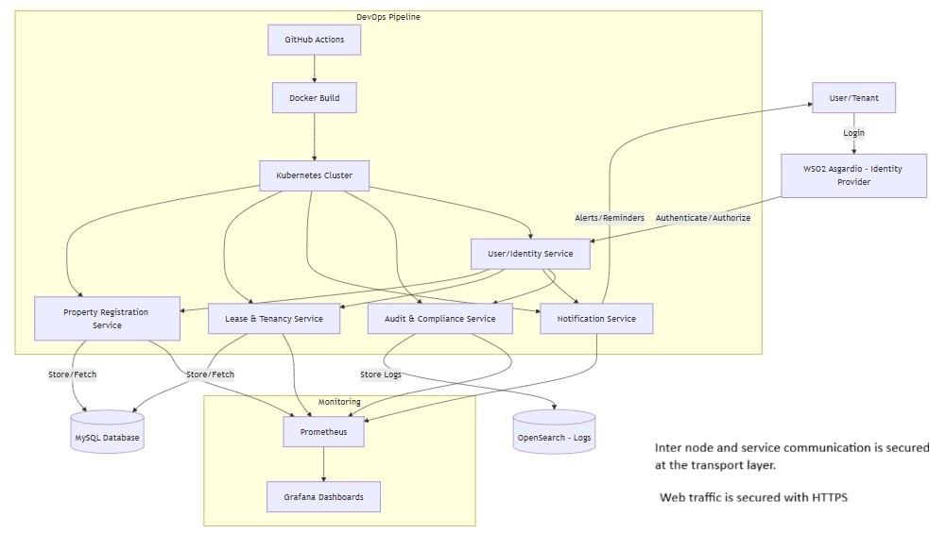
Figure : High Level Architecture
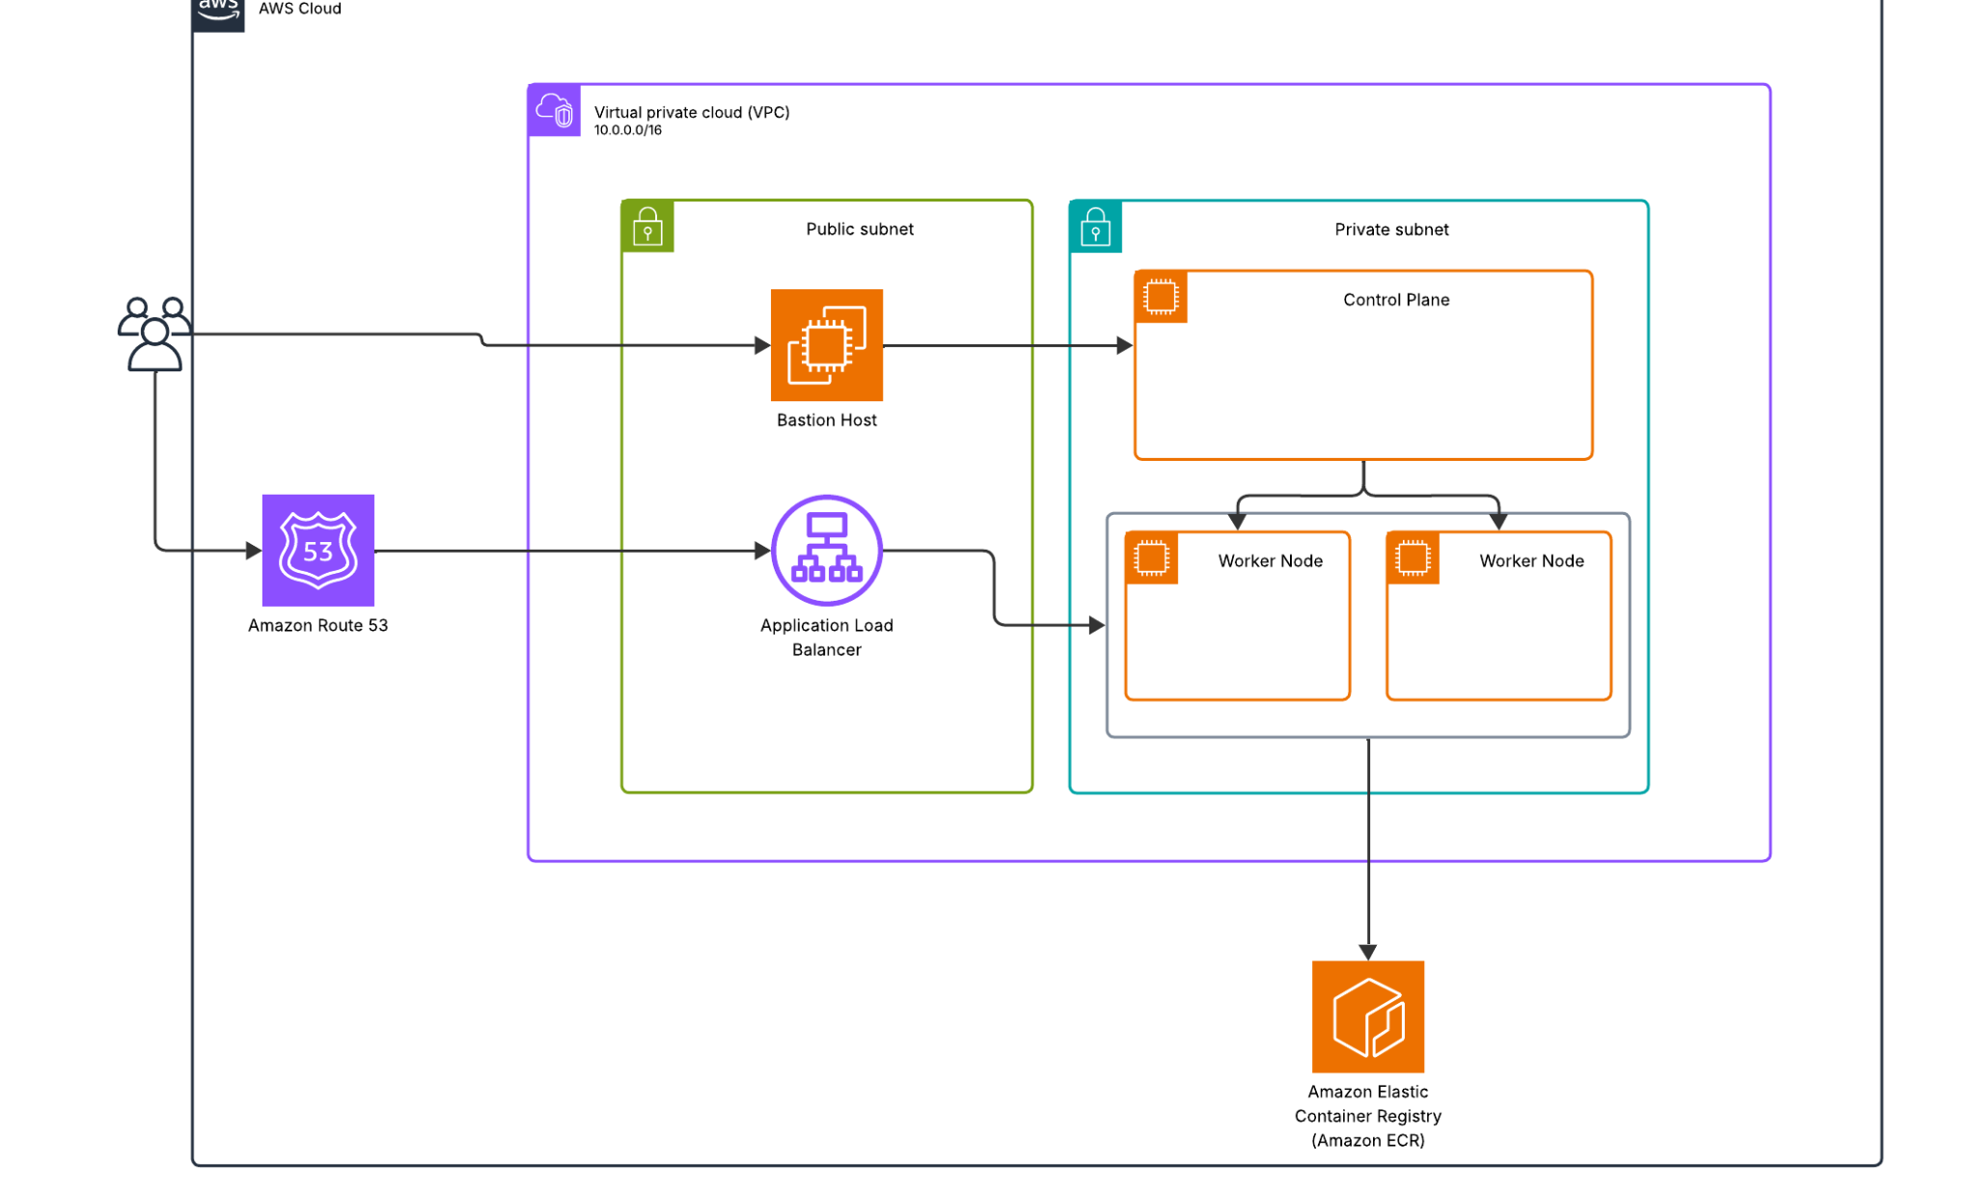
Figure : Deployment Architecture
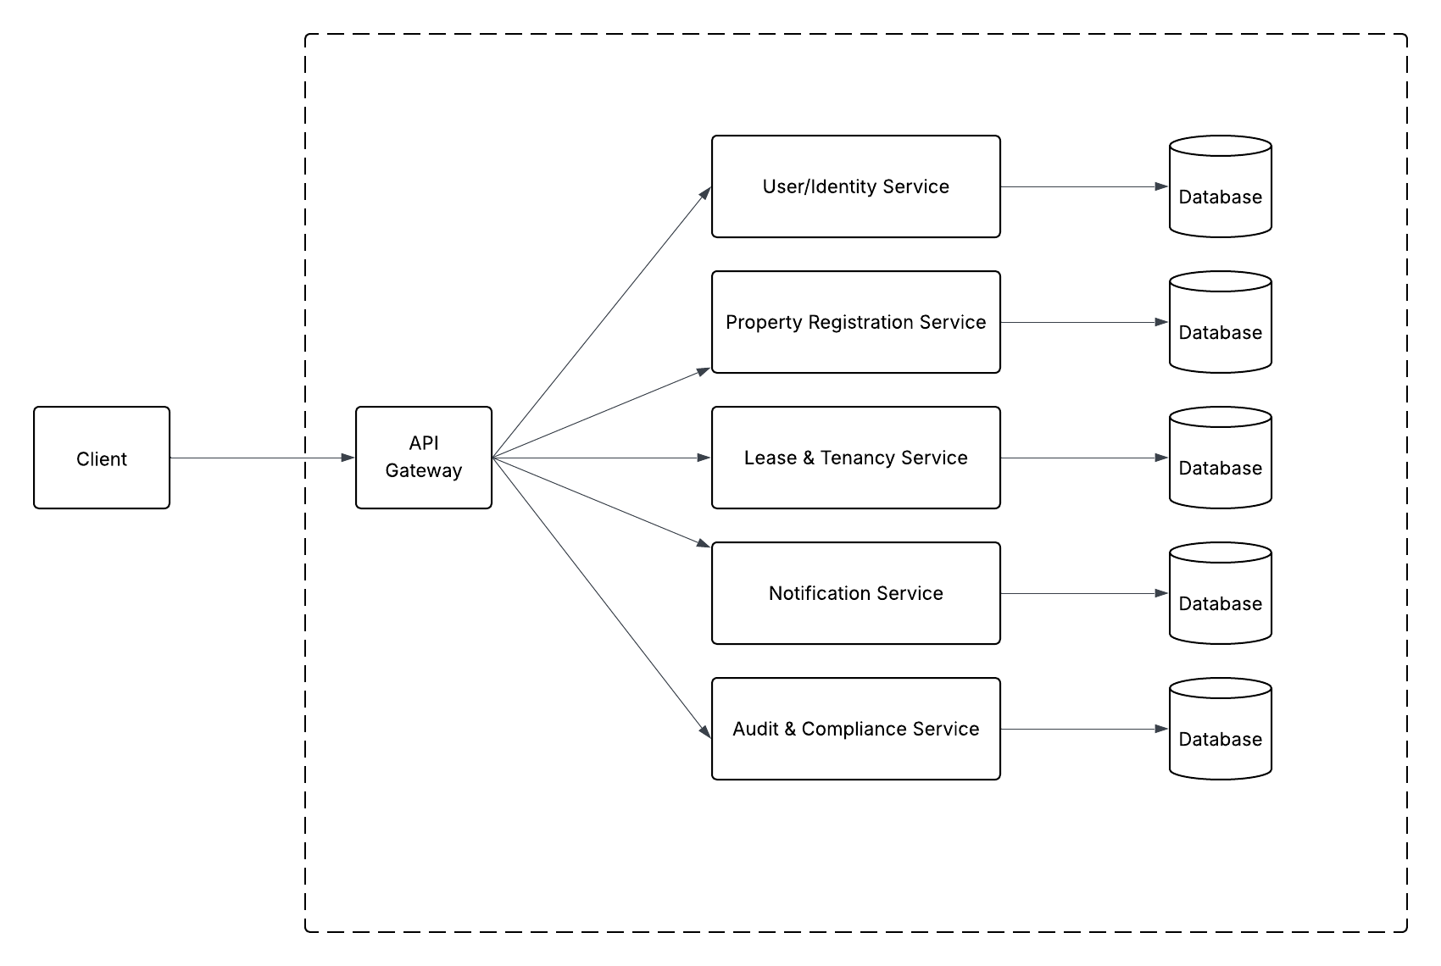
Figure : Microservices Architecture

Technology Stack
The solution will be built using a carefully selected set of technologies to ensure robustness, scalability, and maintainability:
- WSO2 Asgardio: Provides identity federation, SSO, and RBAC.
- Docker: Enables containerization of microservices for consistent deployment.
- Kubernetes: Manages container orchestration, scaling, and service discovery.
- Cilium: Provides identity-aware networking, enforcing mTLS and Zero Trust communication between microservices.
- Ansible: Automates provisioning and setup of Kubernetes clusters across virtual machines.
- MySQL: Stores structured data related to properties, leases, and users.
- Prometheus: Collects and monitors system metrics.
- OpenSearch: Aggregates and analyzes logs for troubleshooting and compliance.
- GitHub Actions & ArgoCD: Automates CI/CD workflows and GitOps-based deployments.

Microservices Design
The system will be composed of the following microservices, each designed to fulfill a specific business function:
- User/Identity Service: Integrates with WSO2 Asgardio to manage user authentication, roles, and permissions.
- Property Registration Service: Handles the creation, updating, and deletion of property records, including buildings, apartments, and land parcels.
- Lease & Tenancy Service: Manages rental agreements, renewals, and tenant allocations, ensuring accurate tracking of lease terms and durations.
- Notification Service: Sends automated alerts for rent due dates, lease expirations, maintenance schedules, and compliance reminders.
- Audit & Compliance Service: Logs user actions and system events to support legal and regulatory compliance audits.
Each service will expose RESTful APIs and adhere to OpenAPI specifications to ensure interoperability and ease of integration.

CI/CD Pipeline
To ensure rapid and reliable delivery of software updates, a robust CI/CD pipeline will be implemented. The pipeline will include:
- Code Monitoring: GitHub repositories will trigger builds upon code changes.
- Build & Containerize: Docker images will be created for each microservice.
- Security Scanning: Tools like Trivy and Aqua will scan images for vulnerabilities.
- Staging Deployment: ArgoCD will sync Kubernetes manifests to the staging environment.
- Manual Approval: QA engineers will validate the staging deployment before production.
- Production Deployment: Canary or Blue-Green strategies will be used to minimize downtime and risk during rollout.
This pipeline ensures continuous integration, automated testing, and safe deployment practices.

Security & Compliance
Security is a cornerstone of this system. A Zero Trust architecture will be adopted, where no component is trusted by default. WSO2 Asgardio will enforce RBAC, ensuring that users only access resources permitted by their roles. All user actions and system events will be logged and indexed in OpenSearch, providing a comprehensive audit trail. Vulnerability scans will be integrated into the CI/CD pipeline to detect and remediate issues before deployment. These measures collectively ensure compliance with industry standards and data protection regulations.

To further strengthen the Zero Trust architecture, the system will integrate Cilium, an eBPF-powered networking and security layer for Kubernetes that enforces mutual TLS (mTLS) between microservices ensuring that all service-to-service communications are both authenticated and encrypted. By enabling mTLS, both client and server microservices exchange cryptographic certificates to verify each other’s identities before communication occurs, effectively eliminating implicit trust within the cluster.

This implementation mitigates risks such as man-in-the-middle attacks, service spoofing, and data interception while Cilium’s Hubble component delivers visibility into encrypted traffic flows to ensure that only authorized and compliant interactions take place.

Monitoring & Log Analysis
Operational visibility will be achieved through a combination of Prometheus and OpenSearch. Prometheus will collect metrics such as CPU usage, memory consumption, and request latency, which will be visualized using Grafana dashboards. OpenSearch will aggregate logs from all microservices, enabling administrators to trace errors, monitor user activity, and identify performance bottlenecks. This observability stack will support proactive maintenance and rapid incident response.

Implementation Plan
The project will be executed over a 10-week timeline, divided into the following phases:
- Week 1–2: Requirements gathering and system architecture design.
- Week 3–5: Development of microservices and database schema.
- Week 6–7: CI/CD pipeline setup and integration.
- Week 8–9: Security hardening and monitoring configuration.
- Week 10: Final testing, documentation, and production deployment.

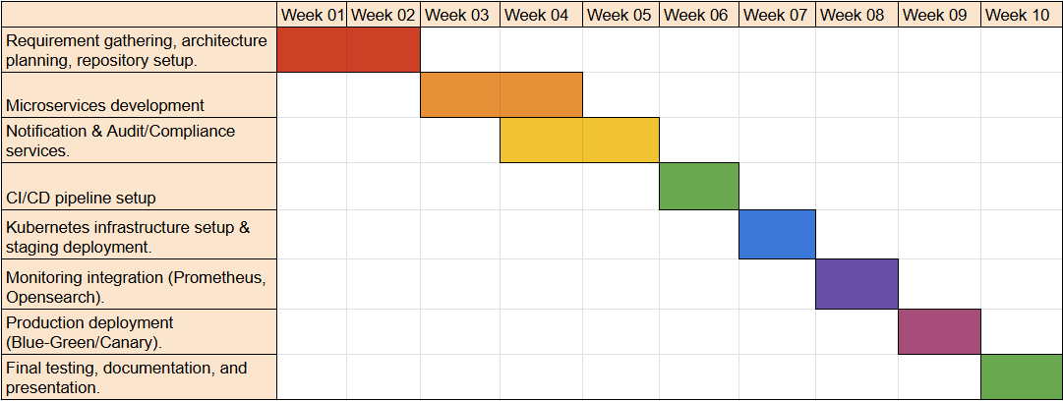
Figure 1: Gantt Chart

The team will include a Project Manager, DevOps Engineer, Backend Developers, QA Engineer, Security Engineer, and Documentation Lead. Weekly stand-ups and milestone tracking will ensure alignment and timely delivery.
Table 1: Team members
Team Member Name | Role | Responsibility
 | Project Manager | Oversees planning, milestones, documentation, and coordination.
 | DevOps Engineer | Implements CI/CD pipeline, manages Kubernetes deployment, and monitoring/logging setup.
 | Backend Developers | Develop microservices (User, Property, Lease, Notification, Audit).
 | QA/Test Engineer | Smoke testing, staging validation, security checks.
 | Security Engineer | Enforce zero-trust policies, vulnerability scans, and compliance checks.
 | Documentation Lead | Prepares deployment guide, final report, ensures knowledge transfer.

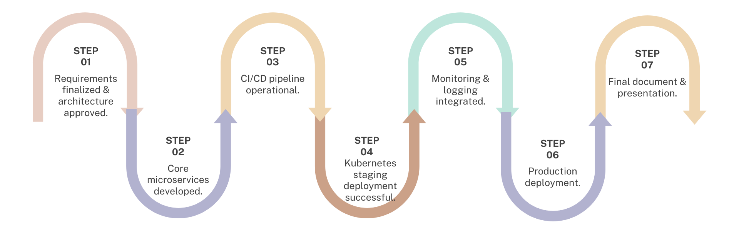
Figure 2: Millstones

Risk Analysis
Risk Analysis and Mitigation Strategies:
- CI/CD Failures: Automated scans and rollback mechanisms will prevent faulty deployments.
- Kubernetes Misconfigurations: Infrastructure as Code (IaC) and automated testing will ensure correctness.
- Identity Breaches: RBAC and Zero Trust principles will minimize unauthorized access.
- Performance Bottlenecks: Auto-scaling policies and Prometheus monitoring will maintain system responsiveness.
- Integration Issues: Early API contract definition and integration testing will ensure service compatibility.
- Team Coordination Delays: Agile practices, weekly stand-ups, and clear role assignments will maintain momentum.

Table 2 : Risk Analysis
Risk | Solution
CI/CD pipeline failure due to vulnerabilities | Use automated vulnerability scans (Trivy, Aqua), fix issues before staging deployment.
Kubernetes misconfiguration leading to downtime | Use Infrastructure-as-Code (Terraform/Helm), automated testing of manifests, and staged rollouts.
Security breaches due to mismanaged identities | Enforce RBAC in Kubernetes, role-based access in microservices, and adopt the Zero Trust model.
Performance bottlenecks under high traffic | Implement auto-scaling policies in Kubernetes, monitor with Prometheus/Grafana.
Lack of integration between services | Conduct early integration testing, use API contracts (OpenAPI specs).
Team coordination issues/delays | Weekly stand-ups, clear division of responsibilities

Conclusion
This Real Estate Management System will deliver a modern, secure, and efficient platform for managing property-related operations. It leverages cutting-edge technologies and best practices in software architecture, security, and DevOps. Upon completion, the system will include source code repositories, deployment guides, and a final presentation/demo to showcase its capabilities.

